|  |  |  |  |  |
| --- | --- | --- | --- | --- |
| CITY OF WESTMINSTER | | | | |
|  |  | | |  |
| INFORMATION TECHNOLOGY | | | | |
|  | | Strategic Plan |  | |

TABLE OF CONTENTS

1. Executive Summary 4

2. Plan Purpose and Introduction 5

3. City and Department Alignment 5

4. City Strategic Plan and IT Implications 5

5. Current State of IT 5

6. Future State of IT 5

7. IT Department Initiatives 5

# Executive Summary

The City of Westminster Information Technology Department Strategic Plan 2024 – 2028 presents a high-level overview of the department’s alignment to the City’s newly updated 2024 Strategic Plan, Mission, Vision, and Guiding Principles.

The Plan also examines the department’s current state and desired future state, as well as departmental initiatives to pursue over the next few years.

The department, an award-winning and highly tenured team, supports the technology needs and initiatives of the City of Westminster. The department has 41 employees, working across software, databases, systems, cybersecurity, and administration.

On the IT Capability Maturity Model, an industry-accepted scale, the department sits squarely in the middle tier of maturity: Trusted Operator. Applications are functional and reliable, service delivery is consistently ranked high, and the department budget and resources are managed appropriately.

The department wishes to move to the next level of maturity: Partner. The Partner role goes beyond *optimizing* the organization using technology to *expanding* the organization via strategic use of analytics and technology.

The department is well-positioned to achieve this next tier of Partner in the next few years. IT receives a high degree of support from City Council. The City has funded several recent position requests, operating budgets, and Capital Improvement Projects to ensure the City’s technology is on the right track. IT will be able to deliver quality data analytics, a secure infrastructure, a stable computing environment, and more technology solutions for years to come.

# Plan and purpose

The City of Westminster Information Technology (IT) Department Strategic Plan 2024 – 2028 provides a high-level overview of the future direction of the department, the current environment, and the initiatives required to achieve the desired future state. The Plan is intended to operate as a living document and provide staff and leadership with a framework by which to prioritize resource needs and allocations, project management, and more.

The Information Technology Department supports the technology needs and initiatives of the City of Westminster. The department has 41 employees, working across software, databases, systems, cybersecurity, and administration. The team benefits from tenured and experienced staff as well as fresh and innovative ideas brought forth from recent hires. A five-person Information Technology Management Team oversees the work of the department, with the IT Director serving on the Executive Leadership Team (ELT).

The department is award-winning, including the achievement ranking top ten nationwide for the last twenty years in the Digital Cities Award Survey, administered by The Center for Digital Government. In 2019 and 2021, the City accepted the First Place Award for Municipalities for the population category of 75,000 to 124, 999.

The IT Department serves many internal customers including City Council, City Manager’s Office, City Attorney’s Office, Community Development Department, Finance Department, Fire Department, General Services Department, Human Resources Department, Parks, Recreation and Libraries Department, Police Department, and Public Works and Utilities Department.

In addition, external customers such as local businesses, residents, and visitors of the City rely on digital services such as the City webpage, online transactions, and live-streaming of Council meetings.

The department’s last strategic plan was adopted in March 2018. In August 2019, a new director was appointed and six months later, the coronavirus pandemic changed the nature of how the department works and delivers services. In response to the virus, the IT department paused some efforts (drafting a new strategic plan, for instance); sped up others (embedding remote work capabilities across the City, for example); and balanced reactive actions to things out of staff control with proactive measures to position the department to remain strategic.

The City of Westminster Information Technology Department Strategic Plan 2024 - 2028 is:

• based on the City priorities it enables, not the technology used to accomplish them.

• supports nimble, reliable, and efficient responses to strategic objectives.

• guides the prioritization of initiatives and investments, focused on driving organizational value, while ensuring alignment between IT and the City organization.

• organizes the department’s financial, technical, and human resources around the City’s guiding principles and strategic priorities providing oversight to manage risks.

• provides focus on decisions affecting long-term investments.

• prioritizes and orders IT initiatives on an enterprise-first approach.

• ensures the wise investment of City dollars on IT initiatives that help achieve organizational goals and objectives while driving future growth.

• enables the alignment of IT activities with City objectives and sets expectations about what can be achieved.

# City and department alignment

In February 2022, City of Westminster Council confirmed the adoption of a revised Mission Statement, Vision Statement, and Guiding Principles. The City’s Vision, Mission, and Guiding Principles directly inform and align the Information Technology Department’s Vision, Mission, and Guiding Principles. Departmental visions, missions, and principles provide a framework that is specific to the nature of the work being done, and therefore are often highly relatable to both front line staff and managers.

|  |  |
| --- | --- |
| **City of Westminster** | **Information Technology** |
| **Vision Statement** | |
| Westminster is a city of beautiful, safe, well-maintained neighborhoods and destinations with a vibrant, diverse economy, rich and resilient environment, and a strong sense of community and belonging. | Westminster Information Technology is a solution-oriented, value-added, business partner in City operations and strategy. |
| **Mission Statement** | |
| The City of Westminster provides high quality core services and fosters resilience in order to promote a safe and thriving community. | Westminster Information Technology drives innovative and effective technology solutions to successfully achieve organizational strategic goals. |
| **Guiding Principles** | |
| Collaboration and Partnership | Partnering |
| Stewardship and Fiscal Responsibility | Value Added |
| Transparency and Accountability | Data Driven |
| Diversity, Equity and Inclusion | Service Oriented |
| Innovate and Initiate | Innovation Seeking |
| Prevention and Proactivity | Secure and Stable |
| Sustainability and Resiliency | Secure and Stable |

The table below lists the City’s statements and principles with the corresponding Information Technology Department’s statements and principles:

**Information Technology Guiding Principles Explanation**

# City Strategic Priorities and IT Implications

In April 2024, City Council adopted updates to the Strategic Plan including a sixth Guiding Principle and a sixth Strategic Priority. The six Strategic Priorities have direct implications for the work of the IT Department.

***Strategic Priority 1: Access to Opportunity***

Implications for IT:

* Provide a strategically diverse technology infrastructure to maximize City services
* Increase the ability for the community to collaborate through technology provided channels

***Strategic Priority 2: Community Empowerment and Engagement***

Implications for IT:

* Provide easy yet protected access to data sources for advanced data analytics
* Partner with public safety to implement forward thinking applications and hardware such as drones, AI based analytics, and early and mass warning systems
* Extend network connectivity to allow access through mobile and personal computing devices

***Strategic Priority 3: Community Health and Safety***

Implications for IT:

* Maintain a robust web presence and platform for social media
* Extend the ability for citizens to interact with the City through electronic means
* Make it easy for citizens to connect with City services and see what the City is doing
* Leverage community partners to enhance services where possible

***Strategic Priority 4: Economic Vitality***

Implications for IT:

* Provide multiple avenues for citizens to interact with the City
* Maintain high visibility around City owned facilities to quickly spot potential issues and resolve them appropriately

***Strategic Priority 5: Resilient Infrastructure***

Implications for IT:

* Maintain a safe and secure environment for employees to work in and services to be delivered through cybersecurity and data protection
* Protect critical systems using industry leading redundancy, failover, backup, and event monitoring technology and strategies
* Test and implement leading edge technologies

**Strategic Priority 6: Organizational Vitality**

Implications for IT:

* Maintain best industry standards in monitoring and evaluation techniques to continually improve operational performance
* Maintain change management methodologies that reduce risk of failure or errors
* Provide a strong development framework for defining technology solutions and implementing them into City services

# Current state of it

Several paths are used to determine the IT department’s current state. The IT Capability Model will be reviewed in context of where the department is now. A recent SWOT Analysis provides insights into strengths, weaknesses, opportunities, and threats. An analysis of the current service structure is provided. In describing a department’s current state, it’s essential to determine a handful of aspects to assess. This Plan explores the department’s maturity level; service structure; and a SWOT analysis, to provide a moment in time snapshot of the department’s current state.

**IT Maturity**

The *IT Capability Maturity Model* is one of several industry-specific frameworks, all very similar, that provide a toolset to evaluate the maturity of the department as related to progressively mature roles: Unstable, Responder, Trusted Operator, Partner, and finally Innovator.

The Westminster Information Technology Department is a solid Trusted Operator for the City in the *IT Capability Maturity Model*. The department routinely delivers a variety of technology services and gets relatively high marks on delivery. Long-term planning happens in some areas more than others. Most services run on a request-respond methodology where needs are assessed as they come up, tending to be somewhat reactionary.

The success of delivery relies heavily on long established relationships with IT Staff throughout the organization. Ironically, or understandably, this can negatively impact or delay service delivery when key staff members leave or retire.

*IT Capability Maturity Model*

**IT Service Structure**

Information Technology consists of management, two divisions (Information Systems and Software Engineering) Business Services office, and an Information Security Office. Information Systems and Software Engineering are broken into more specific service groups.

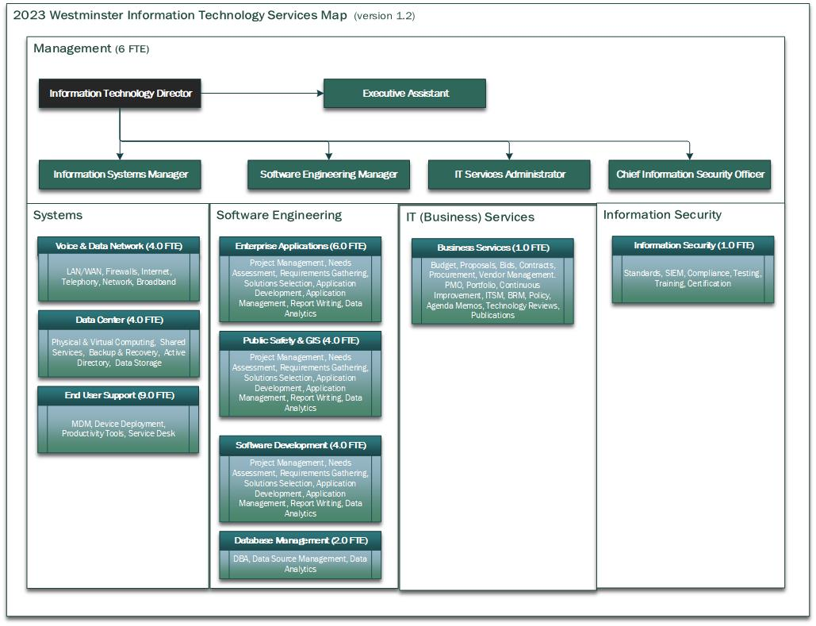

1. Information Technology consists of management, two divisions (Information Systems and Software Engineering) and a Business Services office. Information Systems and Software Engineering are broken into more specific service groups.

**SWOT Analysis (developed in Fall of 2020)**

# FUTURE STate of IT

The City of Westminster IT Department was formed in 1999, from the then Data Processing Division in Finance. Over the last twenty-four years, the City’s needs, and technology’s capabilities, have undergone dramatic growth. It is important for a still-maturing department to have a clear understanding of what to strive for.

The *IT Capability Maturity Model* is one of several industry-specific frameworks, all very similar, that provide a toolset to evaluate the maturity of the department as related to progressively mature roles: Unstable, Responder, Trusted Operator, Partner, and finally Innovator.

The City of Westminster’s IT Department currently sits well within the level of Trusted Operator. City departments consume a variety of IT services and consistently give high marks for delivery. Applications are stable and supported; service desk tickets are completed in a timely manner; and data and infrastructure are protected and secure.

Over the next three years, the IT Department wishes to move firmly into the next level of maturity, from Trusted Operator to Partner. A Partner is one who consistently expands the organization, effectively executing on projects and governing strategic use of both analytics and technology.

The IT Department desires to have a strong consistent partnership with departments that gives insight to IT in departmental direction allowing IT to provide value in the application of technology where it benefits the City.

**IT Strategic Priorities**:

*Provide predictable, resilient, and secure systems, services, and solutions for excellent City services*

The core service of IT is to deliver resilient, predictable, high performing, comprehensive technology to the City from which they can deliver a high quality of service to the community. Information Technology looks for ways to keep its core technology relevant, capable, and available to the City.

*Provide an enhanced customer experience on all services for City users, residents, and businesses*

The City understands the technological sophistication of its community. Information Technology strives to provide the tools necessary to interact with constituents and customers at the level of technology they expect.

*Support access to accurate data through comprehensive data management services to the City*

Information Technology drives the framework necessary to enhance data driven decision making in the City.

*Partner with the City on business solutions including the use of emerging technologies*

Information Technology proactively reaches out to other departments to assist in shaping the direction of core City services. Building on that relationship, Information Technology delivers high quality technology services to the City even in the use of emerging technologies.

*Leverage technology opportunities with external agencies and partners*

The City does not live in a vacuum. Information Technology takes advantage of opportunities with external agencies to deliver the best service possible.

# IT Department initiatives

Clearly defined initiatives provide a roadmap for the IT Department to move from Trusted Operator to Partner as the department continues to oversee a wide variety of technology services to meet the technology needs of the City. IT has set initiatives for the department over the next several years to see that these services meet the demands of the City and deliver a high value to its customers within resource constraints.

These initiatives direct the department’s resources toward maturing IT within the City:

1. Redesign the IT Portal for Better Service

Redesign and implement the IT Portal with a consistent focus of customers and users in mind. Clearly define IT Services and automate the ITSR System to handle as much of the workflow of service requests as possible.

1. Enhance Cybersecurity to Reduce Risk

Continue to prioritize the security of the City’s technology infrastructure and information to reduce risk from cyber activities and other forms of sabotage or intrusion that may threaten the City.

1. Consolidate Technology Costs into IT to Streamlined Service Delivery

Identify distributed costs that are truly technology costs and bring them into the IT operating budget to streamline service delivery.

1. Leverage MS 365 and Azure to Get the most Out of the Tools

Take advantage of 365 through low code/no code solutions using Power Apps, Power Automate, Power BI, SharePoint, and Teams. Use the tools offered to the City through 365 and Teams. Also, leverage the Azure environment by using the data analytics tools, set up serverless computing, and expand cloud storage options.

1. Implement Advanced Data Analytics to Enhance Data Driven Decision Making

Develop and implement a Data Analytics service that appropriately exposes data from multiple data sources through a comprehensive data warehouse solution to enhance the access to understandable information.

